**CSS PROGRAMS**

1.Design a web page exploring different types of CSS Application

**P1_intro.html**

<!DOCTYPE html>

<html lang="en">

  <head>

    <meta charset="UTF-8" />

    <meta name="viewport" content="width=device-width, initial-scale=1.0" />

    <!-- <style>

      h1 {

        font-size: 120px;

      }

    </style> -->

    <link rel="stylesheet" href="CSS_intro.css" />

    <title>CSS Introduction</title>

  </head>

  <body>

    <!-- Inline CSS ->>> BAD BAD Practice -->

    <!-- Internal CSS ->>> used in small amount of code -->

    <!-- External CSS ->>> Best practice -->

    <!-- <h1 style="font-size: 100px">Some Heading</h1> -->

    <h1>Some Heading</h1>

  </body>

</html>

CSS_intro.css

h1 {

  font-size: 100px;

  color: blue;

}

OUTPUT**:-**

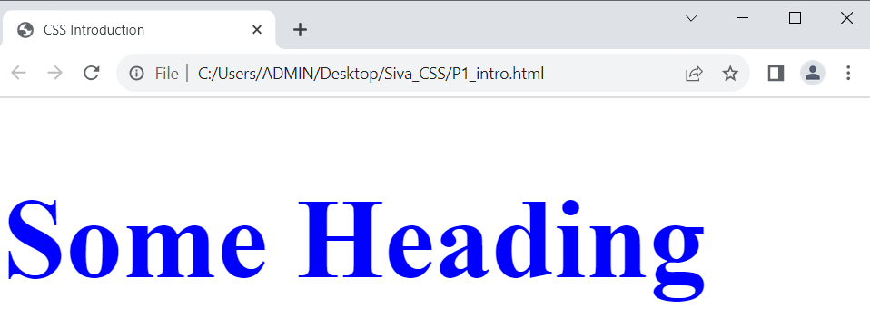

2. Design a web page styling with different Colour Values

**P2_color.html**

<!DOCTYPE html>

<html lang="en">

  <head>

    <meta charset="UTF-8" />

    <meta name="viewport" content="width=device-width, initial-scale=1.0" />

    <link rel="stylesheet" href="CSS_color.css" />

    <title>CSS Colors</title>

  </head>

  <body>

    <section>

      <h1>Welcome to CSS</h1>

      <p>CSS frameworks like Bootstrap, Foundation, and Bulma

    provide pre-written CSS and JavaScript components to streamline

    web development</p>

    </section>

  </body>

</html>

**CSS_colors.css**

/* Hexadecimal color value */

body {

  background-color: #d91c1c;

}

/* HSL color value */

section {

  background-color: hsl(180, 93%, 51%);

}

/* color name */

h1 {

  color: rgb(12, 24, 255);

}

/* RGB color value */

p {

  color: rgb(60, 232, 8);

}

**OUTPUT:**



3. Design a web page styled with Simple CSS Selectors

**P3_simple_selector**

<!DCOTYPE html>

<html lang="en">

    <head>

        <meta charset="UTF-8">

        <meta name="viewport" content="width=device-width, initial-scale=1.0">

        <link rel = "stylesheet" href="CSS_simple_selector.css">

        <title> CSS Simple Selectors </title>

    </head>

    <body>

        <section id = "Course">

            <h1 class ="title"> CSS Bootcamp </h1>

            <p calss = "para"> You will learn CSS here </p>

        </section>

</body>

</html>

**CSS_simple_selector.css**

body

{

    font-family: Arial-black , Helvetica, sans-serif;

}

#course{

    padding:24px;

}

.title {

    font-size: 50px;

}

*{

    margin:0;

    padding:0%;

}

* {

    .title,

    .para

    {

        margin : 10px;

        padding: 15px;

    }

}

**OUTPUT:**

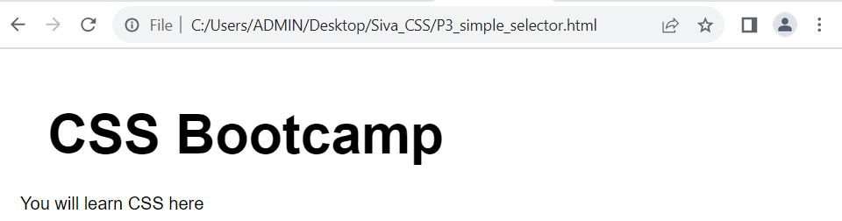

4. Design Design a web page demonstrating the usage of CSS background

<!DOCTYPE html>

<html lang="en">

    <head>

        <meta charset="UTF-8">

        <meta name="viewport" content="width=device-width, initial-scale=1.0">

        <link rel="stylesheet" href="CSS_background.css">

        <title> CSS Background </title>

    </head>

    <body>

        <section> <h1> Title 1 </h1> <p> The Sagan standard is the aphorism that "extraordinary claims require extraordinary evidence". It is named for Carl Sagan (pictured), who used the phrase in his 1979 book Broca's Brain. </p> </section>

        <section> <h1> Title 2 </h1> <p> Various collaborative online encyclopedias were attempted before the start of Wikipedia, but with limited success.[18] Wikipedia began as a complementary project for Nupedia, a free online English-language encyclopedia project whose articles were written by experts and reviewed under a formal process. </p></section>

        <section> <h1> Title 3 </h1> <p> On 24 February 2022, Russia invaded Ukraine in an escalation of the Russo-Ukrainian War that started in 2014. The invasion became the largest attack on a European country since World War II.[12][13][14] It is estimated to have caused tens of thousands of Ukrainian civilian casualties and hundreds of thousands of military casualties. By June 2022, Russian troops occupied about 20% of Ukrainian territory.</p> </section>

        <section> <h1> Title 4 </h1> <p> From a population of 41 million in January 2022, about 8 million Ukrainians had been internally displaced and more than 8.2 million had fled the country by April 2023, creating Europe's largest refugee crisis since World War II. Extensive environmental damage caused by the war, widely described as an ecocide, contributed to food crises worldwide.</p> </section>

        <section> <h1> Title 5 </h1> <p> Before the invasion, Russian troops massed near Ukraine's borders as Russian officials denied any plans to attack. Russian president Vladimir Putin announced a "special military operation" to support the Russian-backed breakaway republics of Donetsk and Luhansk, whose paramilitary forces had been fighting Ukraine in the Donbas conflict since 2014.</p></section>

        <section> <h1> Title 6 </h1> <p> Putin espoused irredentist views challenging Ukraine's right to exist, and falsely claimed that Ukraine was governed by neo-Nazis persecuting the Russian minority. He said his goal was to "demilitarize and denazify" Ukraine. Russian air strikes and a ground invasion were launched at a northern front from Belarus towards Kyiv, a southern front from Crimea, and an eastern front from the Donbas and towards Kharkiv. </p></section>

        <section> <h1> Title 7 </h1> <p> Russian troops retreated from the northern front by April 2022 after encountering logistical challenges and stiff Ukrainian resistance. On the southern and southeastern fronts, Russia captured Kherson in March and Mariupol in May after a destructive siege. </p></section>

    </body></html>

**CSS_background.css**

body {

  color: rgb(55, 0, 255);

  background-image: url("https://images.pexels.com/photos/255379/pexels-photo-255379.jpeg?auto=compress&cs=tinysrgb&w=400");

  background-size: cover;

  background-position: center;

  filter: blur(25);

}

**OUTPUT:**

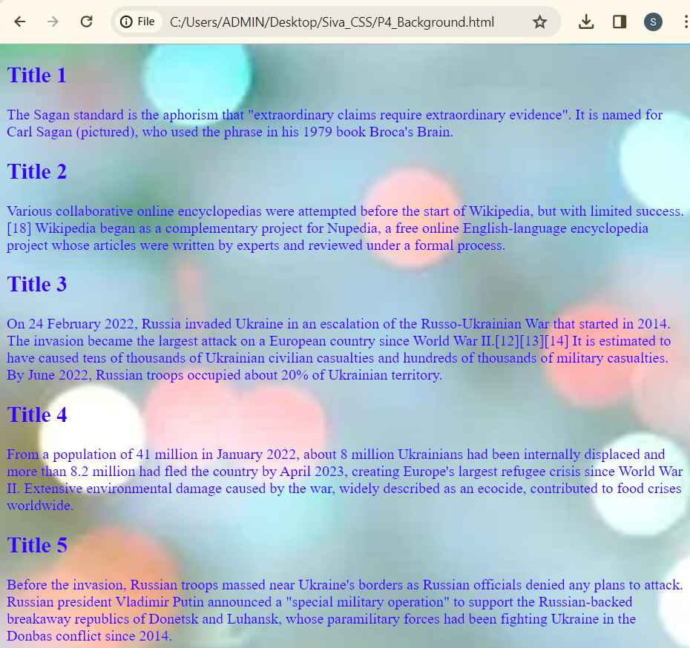

5. Design a web page demonstrating the usage of CSS borders

**P5_borders.html**

<!DOCTYPE html>

<html lang="en">

<head>

    <meta charset="UTF-8">

    <meta name="viewport" content="width=device-width, initial-scale=1.0">

    <link rel = "stylesheet" href="CSS_border.css">

    <title> CSS Borders </title>

</head>

<body>

    <section>

        <h1 class = "title"> CSS Borders </h1>

        <p class = " para "> IN this page, you will learn how to set borders</p>

        </section>

</body>

</html>

**CSS_borders.css**

section {

    border-style:solid;

    border-width: 2px;

    padding: 10px;

    border:blue dashed 3px;

    offset-rotate: ;

}

.para {

    color: rgb(5, 68, 155);

    text-align: center;

}

**OUTPUT:**

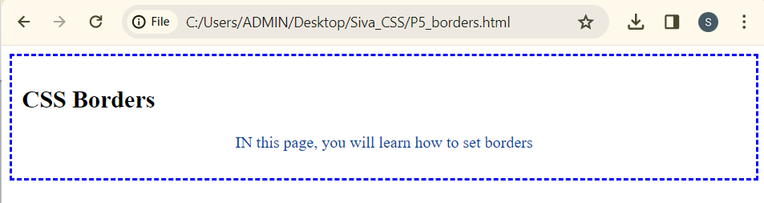

6. Design a web demonstrating the usage of CSS Margins

**P6_margins.html**

<!DOCTYPE html>

<html lang="en">

<head>

    <meta charset="UTF-8">

    <meta name="viewport" content="width=device-width, initial-scale=1.0">

    <link rel="stylesheet" href = "CSS_margins.css">

    <title> CSS Margins </title>

</head>

<body>

    <section>

        <h1 class="title"> CSS Bootcamp </h1>

        <p class="para" > You will learn how CSS borders styling works </p>

    </section>

</body>

</html>

**CSS_margins.css**

section {

    margin-top: 15px;

    margin-right: 20px;

    margin-bottom: 25px;

    margin-left: 30px;

}

section {

    margin: 15px 20px 25px 30px ;

}

**OUTPUT:**

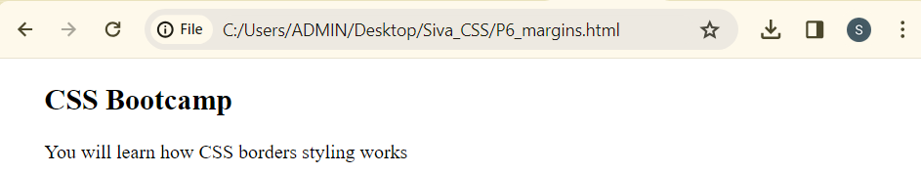

7. Design a web page demonstrating the usage of CSS Padding

**P7_padding.html**

<!DOCTYPE html>

<html lang="en">

<head>

    <meta charset="UTF-8">

    <meta name="viewport" content="width=device-width, initial-scale=1.0">

    <link rel ="stylesheet"  href="CSS_padding.css">

    <title>CSS Padding </title>

</head>

<body>

    <section>

        <h1 class"title"> CSS Bootcamp</h1>

    </section>

</body>

</html>

**CSS_padding.css**

section{

    padding: 15px 20px 25px 30px;

}

**OUTPUT:**

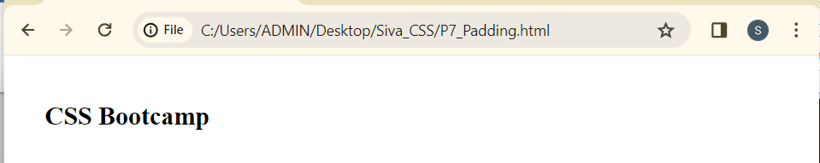

8. Design a web page demonstrating the usage of CSS Height & Weight

**P8_height_width.html**

<!DOCTYPE html>

<html lang="en">

<head>

    <meta charset="UTF-8">

    <meta name="viewport" content="width=device-width, initial-scale=1.0">

    <link rel="stylesheet" href="CSS_height_width.css">

        <title>CSS Height & Width </title>

</head>

<body>

    <section>

        <h1 class ="title"> CSS Bootcamp</h1>

        <p calss = "para"> You will learn CSS. </p>

    </section>

</body>

</html>

**CSS_height_width.css**

section {

    height : 200px;

    width : 600px;

    color: aquamarine;

    padding-left: 25px;

}

**OUTPUT:**

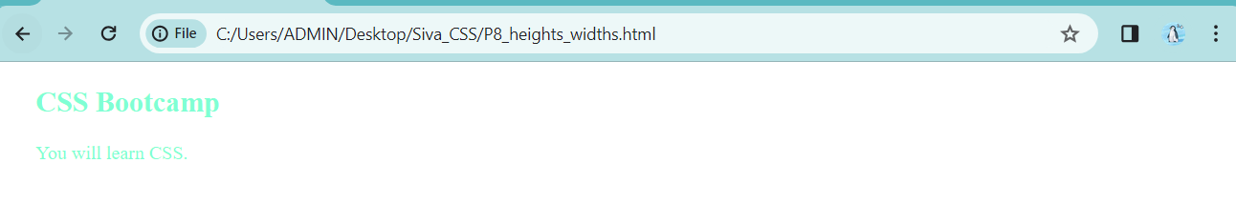

9. Design a web page demonstrating the usage of the CSS Box Model

**P9_box_model.html**

<!DOCTYPE html>

<html lang="en">

<head>

    <meta charset="UTF-8">

    <meta name="viewport" content="width=device-width, initial-scale=1.0">

    <link rel="stylesheet" href="CSS_box_model.css">

    <title>CSS Box Model </title>

</head>

<body>

    <section>

        <h1 class="title"> CSS Bootcamp</h1>

        <p  class="para"> You will learn CSS from here.</p>

    </section>

    <article>

        <h1 class="title"> CSS Bootcamp</h1>

        <p class ="para"> You will learn CSS.</p>

    </article>

</body>

</html>

**CSS_box_model.css**

* {

    box-sizing: border-box;

}

section{

    height: 150px;

    width: 200px;

    padding: 10px;

    border: solid 5px#2419ea;

    margin: 25px;

}

article{

    height: 150px;

    width: 200px;

    padding:10px;

    border: red dashed 10px;

    margin: 25px;

}

body{

    display: flex;

    flex-direction:row;

}

**OUTPUT:**

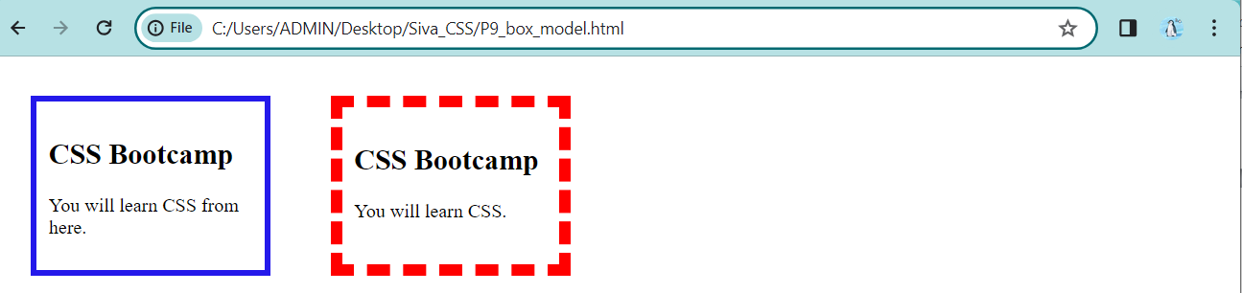

10. Design a web page demonstrating the usage of CSS text Property

**P10_text_property.html**

<!DOCTYPE html>

<html lang="en">

<head>

    <meta charset="UTF-8">

    <meta name="viewport" content="width=device-width, initial-scale=1.0">

    <link rel="stylesheet" href="CSS_text_property.css">

    <title>CSS Text Properties</title>

</head>

<body>

    <section>

        <h1 class="title"> CSS Bootcamp</h1>

        <p class="para"> You will be learning CSS.</p>

    </section>

</body>

</html>

**CSS_text_property.css**

h1 {

    color: coral;

    text-transform: uppercase;

    text-align: center;

}

p{

    text-align: center;

    letter-spacing: 1px;

    word-spacing: 5px;

    text-shadow: 1px 2px 2px black;

}

**OUTPUT:**

**-**

11. Design a web page demonstrating the usage of the CSS font properties

**P11_font_property.html**

<!DOCTYPE html>

<html lang="en">

<head>

    <meta charset="UTF-8">

    <meta name="viewport" content="width=device-width, initial-scale=1.0">

    <link rel="stylesheet" href="CSS_font_property.css">

    <title> CSS Font Properties </title>

</head>

<body>

    <section>

        <h1 class="title"> CSS Bootcamp </h1>

        <p class="para"> You will learn CSS here.</p>

    </section>

</body>

</html>

**CSS_font_property.css**

section{

    font-family: Verdana, Geneva, Tahoma, sans-serif;

}

h1 {

    color: coral;

    text-transform: uppercase;

    text-align: center;

    font-style: italic;

    font-size: 50px;

    font-weight: 32232;

}

p{

    text-align: center;

    letter-spacing: 2px;

    word-spacing: 5px ;

}

**OUTPUT:**

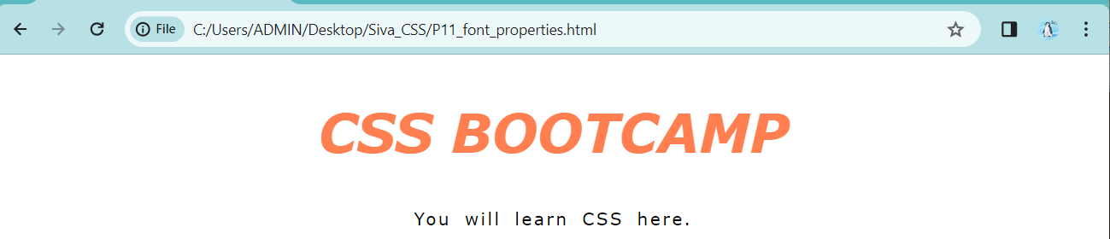

12. Design a web page demonstrating the usage of CSS links

**P12_CSS_Links.html**

<!DOCTYPE html>

<html lang="en">

<head>

    <meta charset="UTF-8">

    <meta name="viewport" content="width=device-width, initial-scale=1.0">

    <link rel="stylesheet" href="CSS_links.css">

    <title>CSS Links </title>

</head>

<body>

    <section>

        <h1 class="title"> CSS Bootcamp</h1>

        <p class="para"> You will learn CSS.</p>

        <a href="#">Read More</a>

    </section>

</body>

</html>

**CSS_links.css**

section{

    font-family: Arial, Helvetica, sans-serif;

    display: flex;

    flex-direction: column;

    justify-content: center;

    align-items: center;

}

h1{

    color: coral;

    text-transform: uppercase;

    font-size: 50px;

}

p{

    letter-spacing: 2px;

    word-spacing: 5px;

    font-weight: bolder;

}

a{

    text-decoration: none;

    background-color: #333;

    padding: 15px;

    margin: 40px;

    color: rgb(255, 255, 255);

    transition: all 0.2s ease-in-out;

}

a:hover{

    box-shadow: 9px 9px 0px rgb(213, 215, 67);

    background-color: rgb(233, 66, 5);

}

**OUTPUT:**

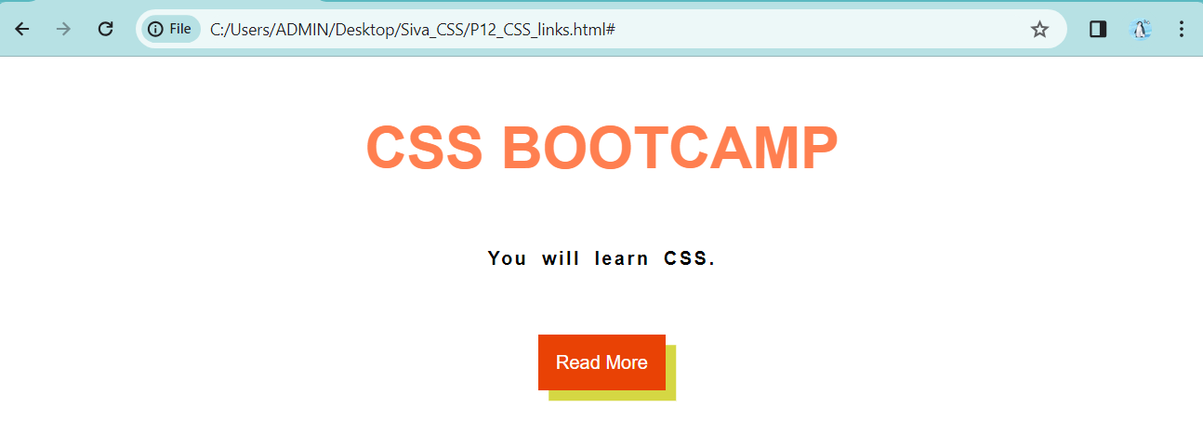

13. Design the web page of demonstrating the usage of CSS Combinators Selectors

**P13_combinators.html**

<!DOCTYPE html>

<html lang="en">

<head>

    <meta charset="UTF-8">

    <meta name="viewport" content="width=device-width, initial-scale=1.0">

    <link rel="stylesheet" href="CSS_combinators.css"/>

    <title>CSS Combinators Selectors </title>

</head>

<body>

    <article id ="tech">

        <h1> Green Technology </h1>

        <p>Green tech is the use of science and technology to develop eco-friendly products and services that protect our environment. It includes renewable energy, sustainable transportation, waste management and recycling, energy efficiency solutions, all helping us move towards a more sustainable future.</p>

        <a href="#"> Read More</a>

        <div>

            <p>Hey There</p>

        </div>

        <a href="#"> Read More Here</a>

        <p> Green technology is an umbrella term that describes the use of technology and science to create products and services that are environmentally friendly. Green tech is related to cleantech, which specifically refers to products or services that improve operational performance while also reducing costs, energy consumption, waste, or negative effects on the environment.

            The goal of green tech is to protect the environment, repair damage done to the environment in the past, and conserve the Earth's natural resources. Green tech has also become a burgeoning industry that has attracted enormous amounts of investment capital.

            The use of green tech can be a stated goal of a business segment or a company. These goals are typically outlined in a company's environmental, sustainability, and governance (ESG) statement, or can even be found in the mission statement of a firm. Increasingly, socially responsible investors are looking to narrow down their prospective investments to only include companies that specifically employ or produce green technologies. </p>

    </article>

</body>

</html>

**CSS_combiantors.css**

#tech h1 {

    font-size: 30px;

}

article>p{

    background-color: rgb(255, 255, 107);

    padding: 15px;

    font-weight: 200;

    font-size: medium;

}

p~a{

    text-decoration: none;

    background-color: rgb(222, 98, 49);

    padding: 15px;

    display: inline-block;

    margin: 30px;

    color: rgb(255, 255, 255);

}

**OUTPUT:**

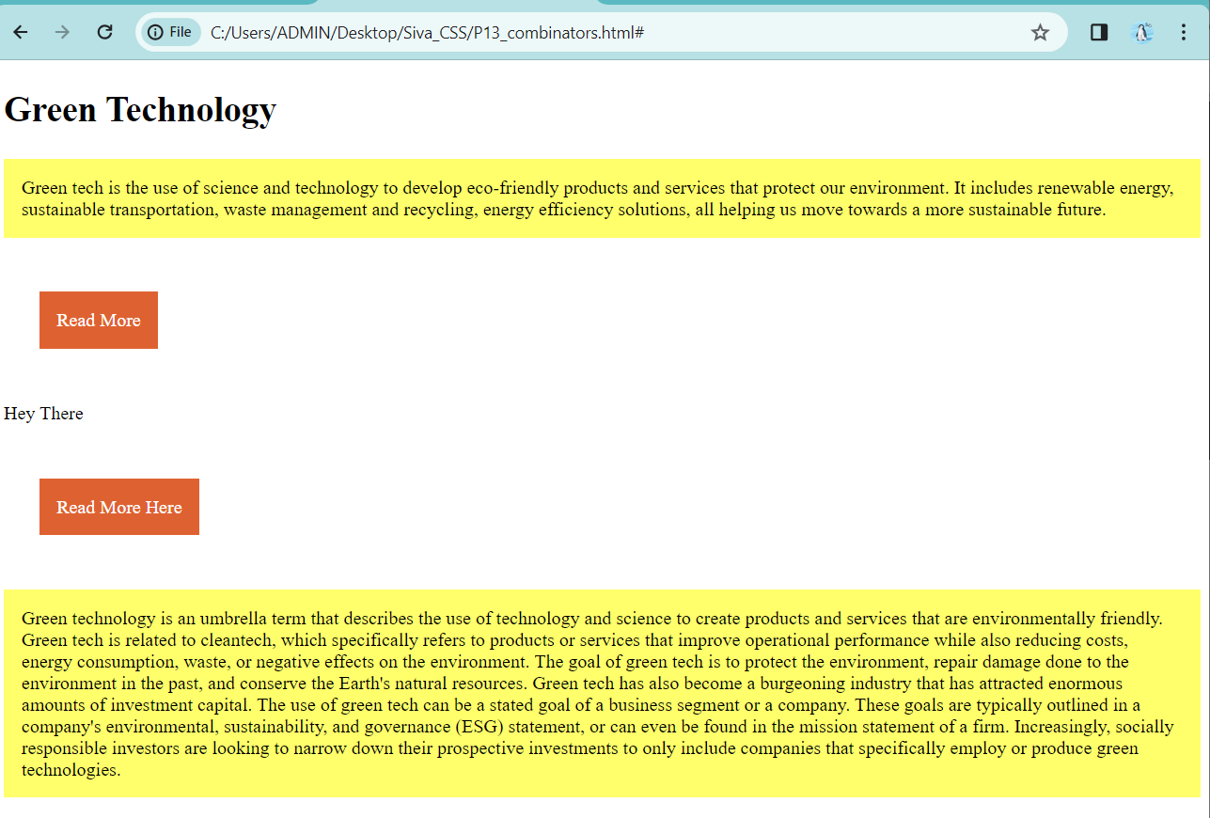

14. Design a web page demonstrating the usage of CSS pseudo classes

**P14_pseudo.html**

<!DOCTYPE html>

<html lang="en">

<head>

    <meta charset="UTF-8">

    <meta name="viewport" content="width=device-width, initial-scale=1.0">

    <link rel="stylesheet" href="CSS_pseudo.css">

    <title>CSS Pseudo Class Section</title>

</head>

<body>

        <article id ="animla-planet">

            <h1> Polar Bears </h1>

            <p class="para">

                The polar bear (Ursus maritimus) is a large bear native to the Arctic and nearby areas. It is closely related to the brown bear, and the two species can interbreed. The polar bear is the largest extant species of bear and land carnivore, with adult males weighing 300–800 kg (660–1,760 lb). The species is sexually dimorphic, as adult females are much smaller. The polar bear is white- or yellowish-furred with black skin and a thick layer of fat.

            </p>

    <a href="https://en.wikipedia.org/wiki/Polar_bear"> Read More </a>

    <div>

        <p> Hey There </p>

    </div>

    <a href="https://en.wikipedia.org/wiki/Polar_bear"> Read More Here </a>

    <p class="para main-para">

        The polar bear was given its common name by Thomas Pennant in A Synopsis of Quadrupeds (1771). It was known as the "white bear" in Europe between the 13th and 18th centuries, as well as "ice bear", "sea bear" and "Greenland bear". The Norse referred to it as isbjørn 'ice bear' and hvitebjørn 'white bear'. The bear is called nanook by the Inuit. The Netsilik cultures additionally have different names for bears based on certain factors, such as sex and age: these include adult males (anguraq), single adult females (tattaq), gestating females (arnaluk), newborns (hagliaqtug), large adolescents (namiaq) and dormant bears (apitiliit).[5] The scientific name Ursus maritimus is Latin for 'sea bear'.[6][7] </p>

    <a href="https://www.worldwildlife.org/species/polar-bear#:~:text=Importance%20of%20polar%20bears,and%20economies%20of%20Arctic%20peoples."> Read More Here</a>

    <br/>

    <br/>

    <button> Click Me!!! </button>

</article>

</body>

</html>

**CSS_pseudo.css**

.main-para{

    padding: 25px;

    background-image: url("C:/Users/ADMIN/Desktop/Siva_CSS/Download.jpg");

    color: rgb(124, 6, 167);

    background-repeat: no-repeat;

    background-size: cover;

}

**OUTPUT:**

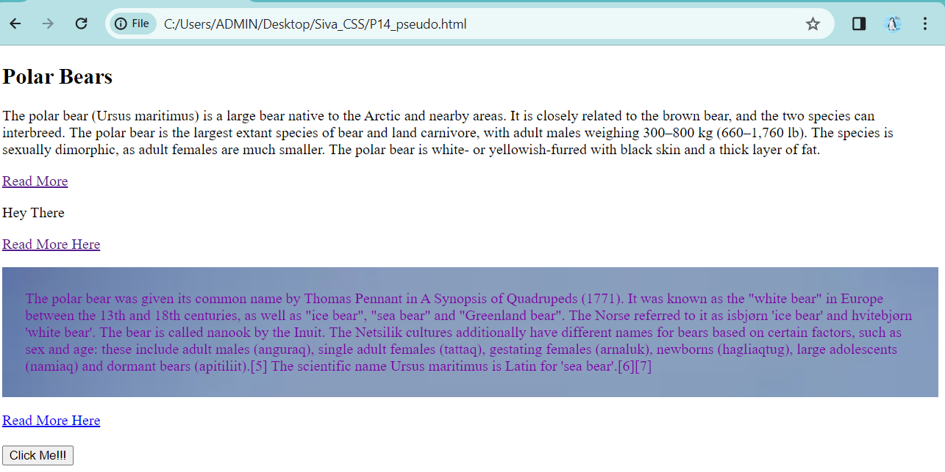

15. Design a web page demonstrating the usage of CSS opacity property

**P15_opacity.html**

<!DOCTYPE html>

<html lang="en">

<head>

    <meta charset="UTF-8">

    <meta name="viewport" content="width=device-width, initial-scale=1.0">

    <link rel="stylesheet" href="CSS_opacity.css">

    <title>CSS Opacity</title>

</head>

<body>

    <p>

        The polar bear was given its common name by Thomas Pennant in A Synopsis of Quadrupeds (1771). It was known as the "white bear" in Europe between the 13th and 18th centuries, as well as "ice bear", "sea bear" and "Greenland bear". The Norse referred to it as isbjørn 'ice bear' and hvitebjørn 'white bear'. The bear is called nanook by the Inuit. The Netsilik cultures additionally have different names for bears based on certain factors, such as sex and age: these include adult males (anguraq), single adult females (tattaq), gestating females (arnaluk), newborns (hagliaqtug), large adolescents (namiaq) and dormant bears (apitiliit).[5] The scientific name Ursus maritimus is Latin for 'sea bear'.[6][7]

    </p>

    <img src="C:\Users\ADMIN\Desktop\Siva_CSS/download.jpg" alt="Bear image">

</body>

</html>

**CSS_opacity.css**

body {

    background-image: url("C:/Users/ADMIN/Desktop/Siva_CSS/download2.jpeg");

    background-repeat: no-repeat;

    background-size: cover;

img{

    height: 300px;

    width: 200px;

    object-fit: cover;

}

img:hover{

    opacity:0.2;

}

p{

    color: #57b0dc;

    padding: 25px;

    font-size: 30px;

    background-color: #4d19191a;

}

p:hover{

    background-color: black;

}

**OUTPUT:**



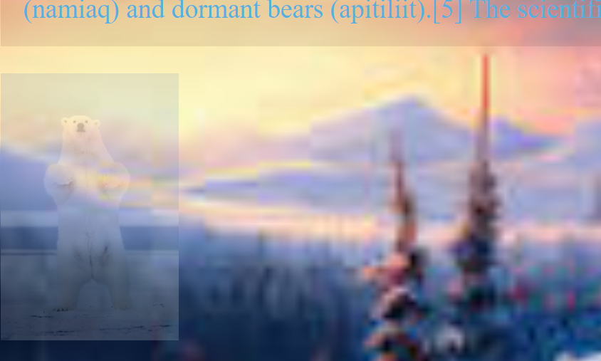

16. Design a web page demonstrating the usage of CSS Attribute Selectors

<!DOCTYPE html>

<html lang="en">

<head>

    <meta charset="UTF-8">

    <meta name="viewport" content="width=device-width, initial-scale=1.0">

    <link rel="stylesheet" href="CSS_attribute.css">

    <title>CSS Attribute Selector</title>

</head>

<body>

    <article id="animal-planet">

        <h1 title="heading-one">Primates</h1>

        <p>Primates are a diverse order of mammals. They are divided into the strepsirrhines, which include the lemurs, galagos, and lorisids, and the haplorhines, which include the tarsiers and the simians (monkeys and apes)</p>

        <a href="https://en.wikipedia.org/wiki/Primate"> Read More</a>

    </article>

    <article>

        <h2> Birds </h2>

        <p>Birds are a group of warm-blooded vertebrates constituting the class Aves (/ˈeɪviːz/), characterised by feathers, toothless beaked jaws, the laying of hard-shelled eggs, a high metabolic rate, a four-chambered heart, and a strong yet lightweight skeleton.</p>

       <a href="https://en.wikipedia.org/wiki/Bird"> Read More Here</a>

    </article>

</body></html>

article[id="animal-planet"]{

    background-color: lightslategray;

    color: white;

    padding: 10px;

}

h1[title="heading-one"]{

    font-size: 25px;

    font-family: 'Franklin Gothic Medium', 'Arial Narrow', Arial, sans-serif;

}

a[href="https://en.wikipedia.org/wiki/Primate"]{

    text-decoration: none;

    background-color: black;

    color: white;

    padding: 10px;

}

**OUTPUT:**

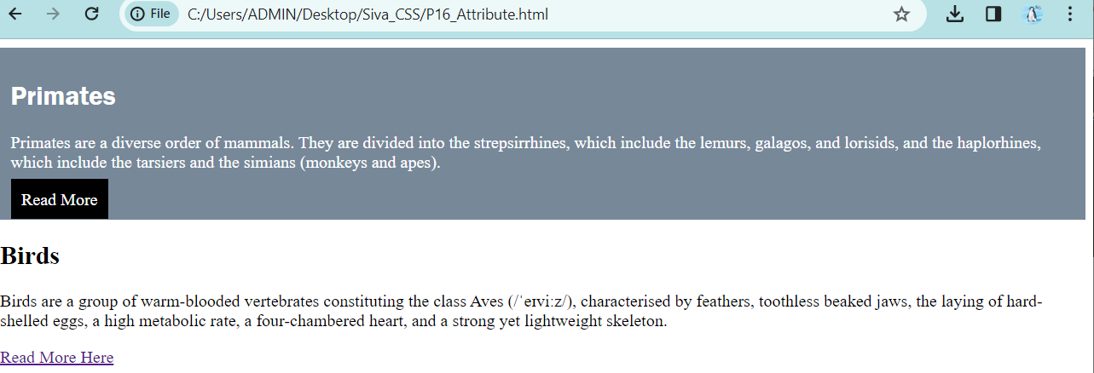

17. Design a web page demonstrating the usage of CSS Specificity

**P17_specificity.html**

<!DOCTYPE html>

<html lang="en">

<head>

    <meta charset="UTF-8">

    <meta name="viewport" content="width=device-width, initial-scale=1.0">

    <link rel="stylesheet" href="CSS_specificity.css">

    <title>CSS Specificity</title>

</head>

<body> <section>

        <h1 id="title" >CSS Bootcamp </h1>

        <p class="para">A comprehensive guide to learning one of the most used web languages of all time.</p>

        <a href="#"> Read More </a>

    </section>

</body> </html>

**CSS_specificity.css**

section{

    background-color: rgb(68, 216, 68); }

#title {

    font-size: 55px; }

h1 {

    font-size: 40px; }

.para {

    color:blue; }

a {

    font-size: 35px; }

p{

    color: blue; }

h1#title{

    font-size: 150px; }

**OUTPUT:**

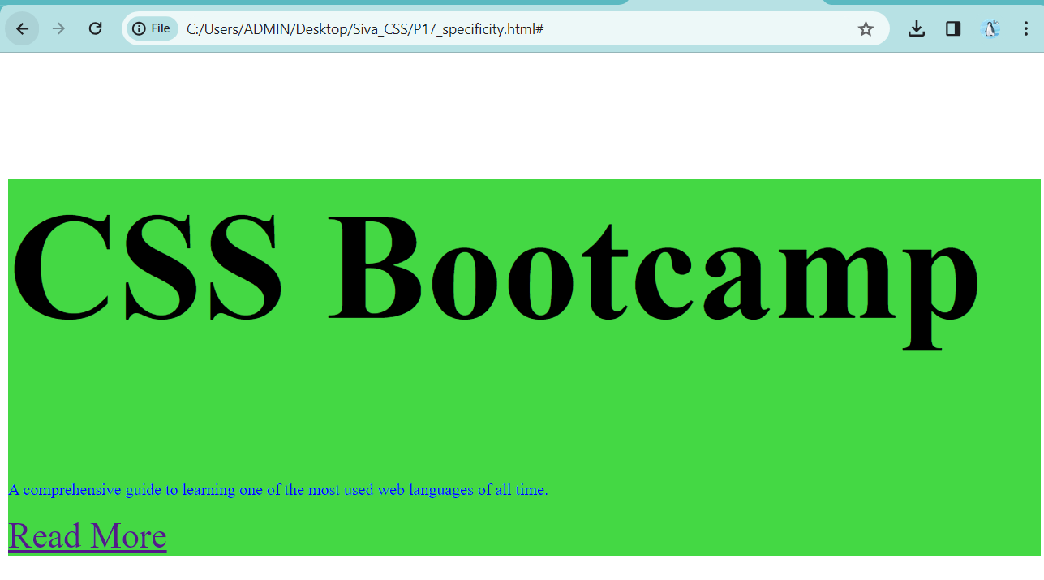

18. Design a web page demonstrating the usage of CSS Border Radius

**P18_border_radius.html**

<!DOCTYPE html>

<html lang="en">

<head>

    <meta charset="UTF-8">

    <meta name="viewport" content="width=device-width, initial-scale=1.0">

    <link rel="stylesheet" href="CSS_border_radius.css">

    <title>CSS Border Radius </title>

</head>

<body>

    <section></section>

    <section></section>

</body>

</html>

**CSS_border_radius.css**

body{

    margin: 0;

    padding: 0;

    height: 100vh;

    display: flex;

    align-items: center;

}

section{

    height: 350px;

    width: 350px;

    background-color: rgb(177, 53, 150);

    margin: auto;

    border-radius: 60%;

}

**OUTPUT:**

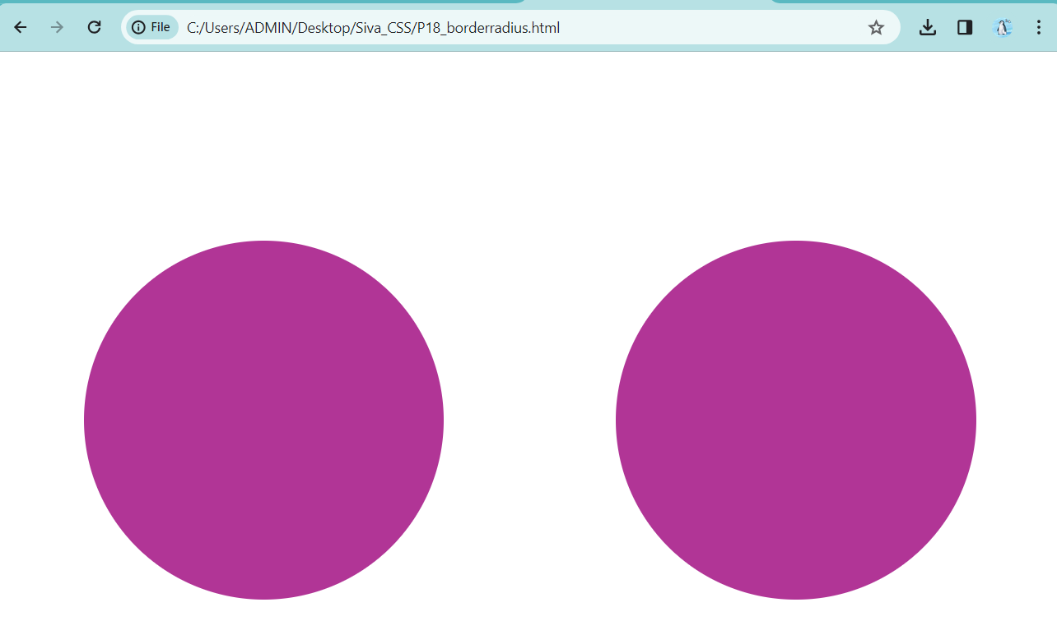

19. Design a web page demonstrating the usage of CSS Box Shadow

**P19_box_shadow.html**

<!DOCTYPE html>

<html lang="en">

<head>

    <meta charset="UTF-8">

    <meta name="viewport" content="width=device-width, initial-scale=1.0">

    <link rel="stylesheet" href="CSS_box_shadow.css">

    <title>CSS Box Shadow </title>

</head>

<body>

    <section> <h1> CSS Bootcamp </h1>

    <p>A comprehensive guide to learning one of the most used web programming languages of all time </p></section>

</body>

</html>

**CSS_box_shadow.css**

section{

    padding: 15px 25px;

    color: #fff;

    font-family: Arial, Helvetica, sans-serif;

    display: inline-block;

    background-color: grey;

    box-shadow: 5px 9px 5px 8px black;

}

**OUTPUT :**

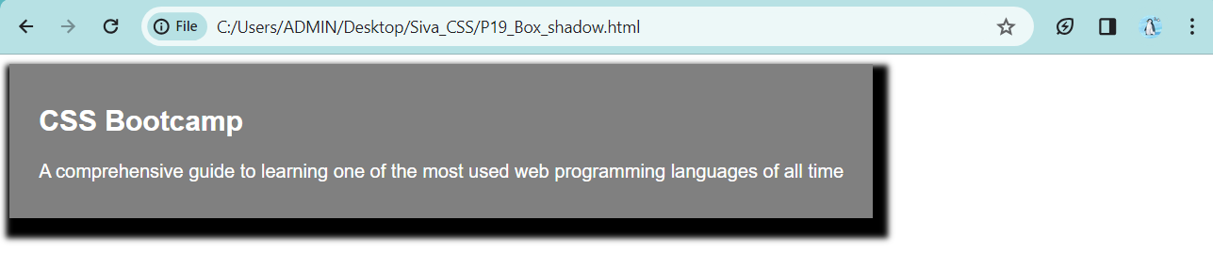

20. Design a web page demonstrating the usage of CSS Gradients

**P20_gradient.html**

<!DOCTYPE html>

<html lang="en">

<head>

    <meta charset="UTF-8">

    <meta name="viewport" content="width=device-width, initial-scale=1.0">

    <link rel="stylesheet" href="CSS_gradient.css">"

    <title> CSS Gradients </title>

</head>

<body>

    <section> <h2 > Chadwick Boseman </h2>

    <p> Chadwick Aaron Boseman (/ˈboʊzmən/;[5] November 29, 1976[a] – August 28, 2020) was an American actor. During his two-decade career, Boseman received several accolades, including two Screen Actors Guild Awards, a Golden Globe Award, and a Primetime Emmy Award, along with an Academy Award nomination.</p></section>

</body>

</html>

**CSS_gradient.css**

section{

    padding: 25px;

    color: white;

    height: 150px;

    background-image: linear-gradient(#abdcff, #0396ff);

  background-image: linear-gradient(to right, #43cbff, #9708cc);

  background-image: linear-gradient(to top, #92ffc0, #002661);

  background-image: linear-gradient(to bottom, #92ffc0, #002661);

  background-image: linear-gradient(to left,  hsl(131, 100%, 25%), #0000f9, rgb(134, 0, 125) );

}

**OUTPUT:**

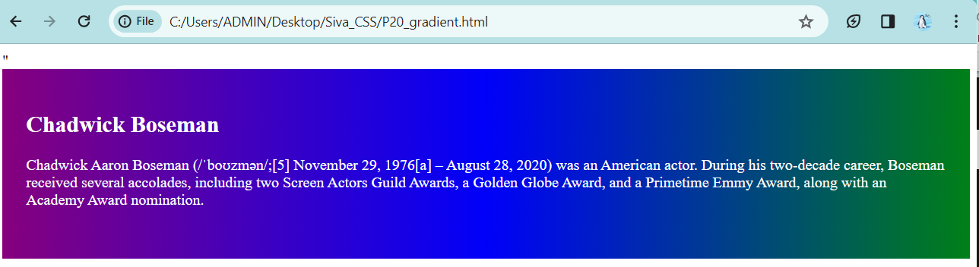

21. Design a web page demonstrating the usage of CSS transforms

**P21_transforms.html**

<!DOCTYPE html>

<html lang="en">

<head>

    <meta charset="UTF-8">

    <meta name="viewport" content="width=device-width, initial-scale=1.0">

    <link rel="stylesheet" href="CSS_transforms.css">

    <title>CSS Transforms</title>

</head>

<body>

    <div class="block">Here we go </div>

</body>

</html>

**CSS_transforms.css**

.block{

    margin: 20px;

    height: 200px;

    width: 200px;

    padding: 10px;

    background-color: teal;

    transform:scale(1.2);

}

div:hover{

    color: rgb(245, 245, 245);

    background-color: crimson;

    transition-duration: 1000ms;

}

**OUTPUT:**

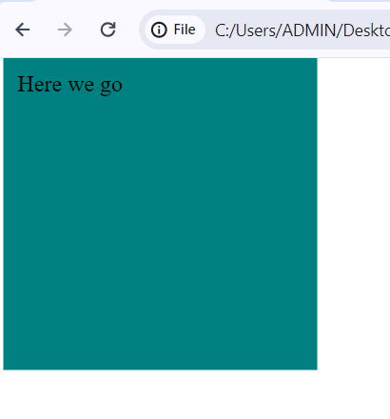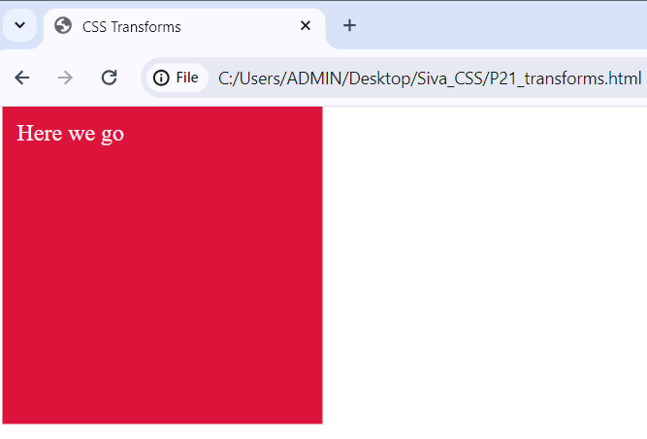

22. Design a web page demonstrating usage of CSS transitions

**P22_transitions.html**

<!DOCTYPE html>

<html lang="en">

<head>

    <meta charset="UTF-8">

    <meta name="viewport" content="width=device-width, initial-scale=1.0">

    <link rel="stylesheet" href="CSS_transition.css">

    <title>CSS Transitions </title>

</head>

<body>

    <div id="block"></div>

</body>

</html>

**CSS_transitions.css**

body{

    margin: 0;

    height: 100vh;

    display: grid;

    place-items: center;

}

#block {

    height: 250px;

    width: 250px;

    background-color: orange;

    transition: all 1s ease-in-out;

}

#block:hover{

    transform: rotate(1turn);

    border-radius: 50%;

    background-color: rgb(24, 96, 174);

}

**OUTPUT:**

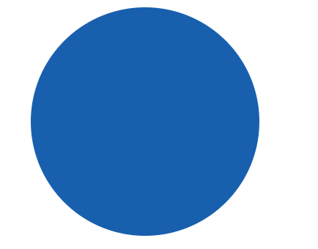

23. Design a web page demonstrating the usage of CSS animations

**P23_animations.html**

<!DOCTYPE html>

<html lang="en">

<head>

    <meta charset="UTF-8">

    <meta name="viewport" content="width=device-width, initial-scale=1.0">

    <link rel="stylesheet" href="CSS_animations.css">

    <title>CSS Animations </title>

</head>

<body>

    <div class="block"></div>

</body>

</html>

**CSS_animations.css**

.block {

    height: 100px;

    width: 100px;

    background-color: lawngreen;

    animation-name: my-first-anime;

    animation-duration: 10s;

}

@keyframes my-first-anime {

    0%{

        transform: translate(0);

    }

    25% {

        transform: translate(250px,0);

    }

    50%{

        transform: translate(250px,150px);

    }

    75%{

        transform: translate(0,150px);

    }

    100% {

        transform: translate(0);

    }

}

**OUTPUT:**



24. Design a web page demonstrating the usage of CSS filters

**P24_filters.html**

<!DOCTYPE html>

<html lang="en">

<head>

    <meta charset="UTF-8">

    <meta name="viewport" content="width=device-width, initial-scale=1.0">

    <link rel="stylesheet" href="CSS_filter.css">

    <title>CSS Filters </title>

</head>

<body>

    <img src="download_bird.jpg" alt =""/>

</body>

</html>

**CSS-filter.css**

img{

    height: 600px;

    width: 700px;

    object-fit: cover;

    filter: blur(10px);

    filter: brightness(5%);

    filter: grayscale(100%);

    filter: contrast(10%);

    filter: opacity(0.8);

    filter: saturate(150%);

    filter: sepia(50%);

}

**OUTPUT:**

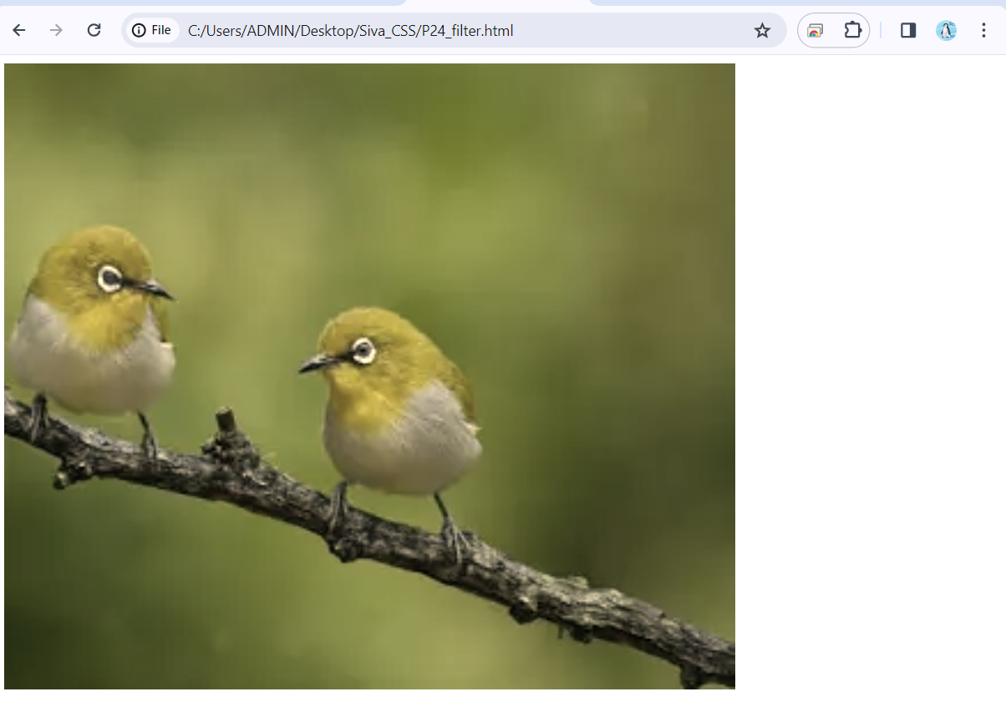

25. Design a web page demonstrating the usage of CSS clip path

**P25_clip_path.html**

<!DOCTYPE html>

<html lang="en">

<head>

    <meta charset="UTF-8">

    <meta name="viewport" content="width=device-width, initial-scale=1.0">

    <link rel="stylesheet" href="CSS_clip_path.css"/>

    <title>CSS Clip Path </title>

</head>

<body>

    <img src="download16.webp" alt=""/>

</body>

</html>

**CSS_clip_path.css**

img {

    height: 500px;

    width: 750px;

    object-fit: cover;

    clip-path: polygon(30% 0, 75% 0, 100% 0, 75% 100%, 0 100%, 0 100%);

}

**OUTPUT:**

